CREDIT CARD FRAUD DETECTION USING MACHINE LEARNING
Scope and Limitations
Department of Computer Science and Engineering, TKR College of Engineering & Technology
Batch A4 (CSE-A) · Academic year [ACADEMIC YEAR]
Table 1: Project team
S.No. | Student name | Roll number
1 | ARELLI PRAVEEN KUMAR | 23K91A0513
2 | BANOTHU AJAY | 23K91A0529
3 | D CHANDRIKA | 23K91A0557
4 | BAIRAGONI VIJAY | 23K91A0525

Project guide: KOTESHWAR RAO
Chapter and section numbers quoted in the text (for example Chapter 8 or Section 6.2) refer to the full project report, 17.Final Document. Figures and tables in this document are numbered from 1.

1. SCOPE

1.1 What is in scope
SecurePay AI covers the path from a table of card transactions to a risk decision, together with the means of inspecting and retraining the models. In detail the scope includes:
Table 2: Features in scope and where they live
Area | What the project provides | Where
Data | A synthetic, labelled file of 39,000 transactions (19,500 fraud, 19,500 legitimate); regeneration with chosen sizes from 500 to 50,000 per class | backend/synthetic_data.py, Lab screen
Preprocessing | One-hot encoding, z-scoring of 24 numeric columns, correlation filter, undersampling (SMOTE and Tomek links optional), top-k feature selection, stratified split | backend/preprocessing.py
Models | Three GRBM classifiers (PCD, SAS, QS) and their mean as an ensemble; per-epoch history; QUBO matrix | rbm_classifier.py, samplers.py, train.py
Single check | One transaction in, fraud probability, per-model probabilities, risk band and recommended action out | /api/predict_single, Verify screen
Bulk screening | A CSV in, a prediction and probability for every row, metrics when a Class column exists, a CSV out | /api/predict_batch, Bulk screen
Analytics | Fraud rate by merchant, channel, hour, amount band, card presence and country match over the whole file | /api/dataset_stats, Analytics screen
Model views | Comparison table, training curves, feature importance, QUBO heat-map | Model comparison screen
Evaluation | Held-out metrics, baselines, seeds, thresholds, low-fraud variant, latency, smoke test | scripts/

1.2 What is out of scope
• Real transaction data. No bank or fintech data were available; every result is on synthetic data.
• Quantum hardware. The quantum sampler is a classical simulation and no D-Wave or other quantum service is called.
• Production concerns: authentication, authorisation, encryption in transit, audit logging, rate limiting, high availability and a production web server.
• Streaming scoring, card-holder history features, delayed labels and drift handling.
• Model governance: explainability reports for regulators, fairness analysis and human review workflows.
• A database. State is kept in memory, CSV, pickle and JSON files.

1.3 Intended users and use
The interface is written for two roles: a merchant or analyst who wants to check one payment, and a risk-operations user who screens CSV exports and reads analytics. The project is a prototype for study and demonstration. The landing page itself says that the models are trained on a synthetic dataset and are not for production payments, and the documentation repeats that limit.

2. ASSUMPTIONS
The results and the design rest on the following assumptions. They are stated so that a reader can judge how far the numbers travel.
• The synthetic generator is an adequate stand-in for a balanced, undersampled card-fraud set. Fraud transactions are drawn with larger amounts (mean 368.20 against 85.21), more online and card-not-present use, more country mismatches and shifted values in five anonymised features. Real fraud is subtler.
• The 50/50 balance of the file reflects the base paper's manual undersampling and is not the balance of a live stream, where fraud is a small fraction of one percent.
• A random 8,000-row sample of the file is large enough to train the three models, and a stratified 80/20 split of it (6,400 training and 1,600 test rows) is a fair held-out set.
• The hyper-parameters reported in the base paper (hidden units, batch size, learning-rate shape) are reasonable for this data and are not re-tuned.
• Transactions arrive with the same columns, units and encodings as the training file. The API does not validate ranges.
• All timings were taken on one Windows PC with a CPU only, with the Flask development server and the API reached at 127.0.0.1.
• The 0.5 decision threshold and the 0.4 and 0.7 risk bands are product choices and were not tuned on validation data.

3. LIMITATIONS
This section lists the limitations that matter for reading the results. Each one was either measured or can be checked in the code.

3.1 Synthetic data
Every number in this report comes from a synthetic file. Its fraud and legitimate classes differ by construction: a logistic regression separates them with F1 96.7%, almost as well as a random forest (96.3%). Real transactions are expected to overlap far more, and published results on real data are much lower: the best fusion of tree models in a recent study reaches an AUPRC of about 0.67 on a public benchmark with 3.5 % fraud [3]. The results therefore show that the pipeline works end to end; they do not predict real-world detection rates. The anonymised features V1 to V22 are essentially noise apart from five shifted ones (and a small amount-linked offset in V1), and the interface labels V3, V14 and V17 as history, location variance and spending pattern only as friendly names.

3.2 Quantum-inspired, not quantum
The base paper's third trainer ran on quantum hardware [1]. Here it is a classical simulation, and the annealing sampler is simplified: both samplers compute the hidden field from the mean visible vector of the batch and tile a single averaged model sample over the batch, and each epoch uses a 3,000-row subsample with 10 sweeps and 16 reads. Training times of a few seconds therefore do not reproduce, and say nothing about, the hours reported in the paper; the interface shows the paper's times in a separate column for that reason.

3.3 Optimistic epoch selection
The comparison view and the dashboard report each model at its best epoch, chosen on the same test split that scores it. That choice is optimistic. The best-epoch F1 of the shipped PCD model is 80.0% (epoch 12), but the saved model is the final epoch, with F1 70.9%. This report uses final-epoch figures as the primary numbers and shows best-epoch values only where it says so.

3.4 Pipeline order
Undersampling and feature selection run on the whole sample before the train-test split, and the scaler is fitted on all rows. Test rows therefore influence which features are kept and how they are scaled. With a balanced synthetic file the effect is small, but it is a leak that a real study would remove.

3.5 Unstable and badly placed classical model
The PCD trainer is unstable: over five seeds its final-epoch F1 is 69.2 +/- 23.1, and the shipped model flags nearly every transaction at the 0.5 threshold (accuracy 58.8%, recall 100.0%, 660 false positives among 795 legitimate test rows) although its ROC-AUC is 0.986. The ensemble averages it with the other two models, so a badly placed member still moves the mean.

3.6 Bulk-route defect
The bulk route (predict_batch) calls the fitted scaler on only the selected numeric columns (13 of the 24 it was fitted on). scikit-learn raises an error, a bare except: pass swallows it, and the models receive unscaled values. On a fresh balanced batch of 2,000 rows accuracy is 50.2% as served against 94.8% when scaled (995 false positives against 26). The bundled sample file of 20 rows (10 fraud) is flagged 20 times as served and 11 times when scaled. The single-check route is not affected. The defect is documented and measured but was not fixed, so the bulk screenshot shows the behaviour of the code as shipped.

3.7 Imbalance behaviour
The models were trained and evaluated on balanced data. At 1% fraud, an RBM trained on undersampled data keeps a precision of 0.95 but finds only 0.59 of the fraud, and the three baselines trained on undersampled data produce hundreds of false alarms per 7,800 transactions. A deployment would need cost-aware thresholds chosen on a realistic stream.

3.8 Engineering limits
• No authentication, no HTTPS, open cross-origin access and the Flask development server (with debug mode on in app.py).
• Only a read-only smoke test of the API (20/20 checks) exists; there is no unit-test suite and no regression test for the scaling defect.
• In-memory state: training from the Lab overwrites the shipped model files, and regenerating the dataset empties the in-memory models.
• The batch route rewrites data/batch_predictions.csv on every call, so concurrent users would overwrite each other's downloads.
• The risk label for a probability of exactly zero is undefined in the batch route because pd.cut excludes the lower edge.

3.9 What the limitations mean for the reader
The limitations do not affect all claims equally. The statements that hold regardless of the data are the structural ones: that the pipeline runs end to end, that the three trainers behave differently from each other and from ordinary baselines on the same split, that accuracy misleads at low fraud rates, and that a swallowed exception in the serving path changes the answers a user sees. The statements that depend on the data are the absolute values: an F1 near 94 % for the ensemble, near 96 to 97 % for the baselines, and precision near 0.95 at one percent fraud. These describe an easy synthetic problem and should not be quoted as expected performance on card transactions.
Table 3: Which claims each limitation affects
Limitation | Claims affected | Claims not affected
Synthetic data | All absolute metrics; comparison with the base paper | Relative behaviour of trainers; effect of resampling; the serving defect
Quantum-inspired sampler | Any statement about quantum training or its time | PCD results; the structure of the classifier
Best-epoch display | Dashboard and comparison-screen F1 values | Final-epoch figures used in this report
Split after selection | Small optimism in all test metrics | Ordering of models; baseline comparison on the same split
Scaling defect | Everything shown on the Verify and Bulk screens | Offline metrics, which use scaled inputs
No real-world test | Any claim of fitness for payments | The engineering findings

Three figures illustrate the limitations that matter most for reading the numbers. The first shows the synthetic, balanced dataset all results rest on; the second shows what happens to a model trained on undersampled data when fraud falls to 1 % of the stream; the third shows the effect of the serving-path defect on a fresh batch.
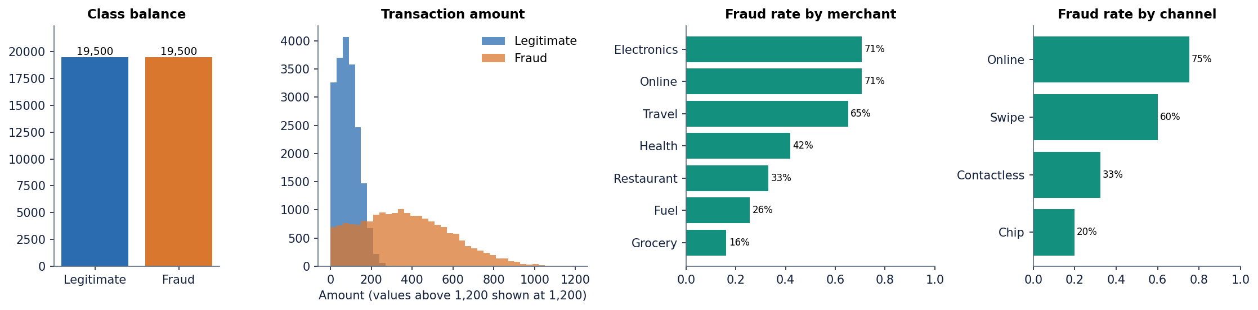
Figure 1: The synthetic, balanced dataset behind every result (limitation: no real transaction data).
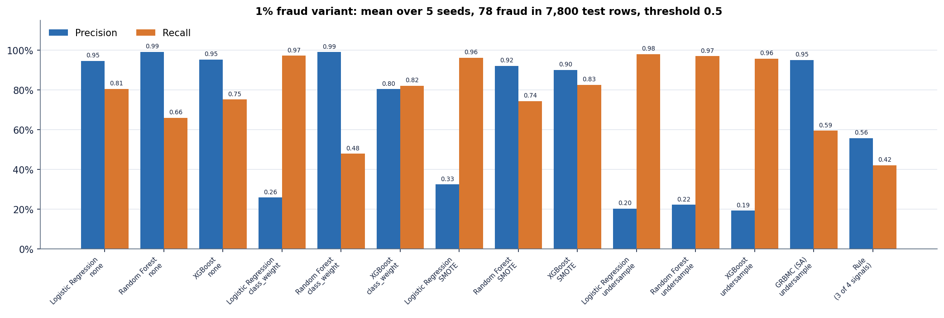
Figure 2: Precision and recall at 1 % fraud for each model and imbalance strategy (limitation: results change with the fraud rate).
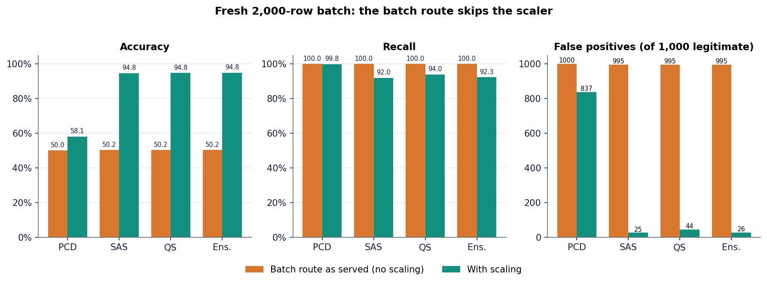
Figure 3: Effect of the skipped scaling step on a fresh 2,000-row batch (limitation: serving-path defect, documented and not fixed).

4. WHAT WAS NOT MEASURED
The following were not measured, so no figure is given for them:
• Precision and recall on real card transactions, and any result at the scale of the base paper (145 million transactions).
• Behaviour under concept drift, delayed labels or changing fraud tactics.
• Throughput and latency under concurrent load; latency was measured for one client at a time.
• Behaviour on hardware other than the single Windows PC used here, and on a production web server.
• Any run on quantum hardware or on a physical annealer; the training times reported in the base paper were not reproduced.
• Usability: no user study was run with analysts or merchants.
• Cost-weighted performance: the cost of a missed fraud against a false alarm is not known for this prototype.
• The effect of a scaling fix on the interface; the defect was measured offline and the product code was left unchanged.

